Program Book
Community Service Project

AP STATE COUNCIL OF HIGHER EDUCATION
(A STATUTORY BODY OF GOVERNMENT OF ANDHRA PRADESH

Program Book for
Community Service Project

Name of the Student: Maleeha Nazneen Abdul
Molla Sabeena
N.Sree Charitha
Naseeka Narmin

Name of the College: Ravindra college of engineering for women

Registration Number: 223T1A3125
223T1A3126
223T1A3127
223T1A3128

Period of CSP:8 weeks
From: To:
Name & Address of the Community/Habitation:

Instructions to Students for Community Service Project

Please read the detailed Guidelines on Community Service Project hosted on the website of AP State Council of Higher Education https://apsche.ap.gov.in

Link: https://apsche.ap.gov.in/Pdf/Guidelines%20for%20the%20OJT%20Internship
%20Community%20Service%20Project.pdf

- It is mandatory for all the students to complete 2 months (180 hours) of Community Service Project as a part of the 10 month mandatory internship/on the job training.
- Consider yourself as a committed volunteer in the community, you work with.
- Every student should identify the village/community/habitation for Community Service Project (CSP) in consultation with the College Principal/the authorized person nominated by the Principal.
- Report to the community/habitation as per the schedule given by the College. You must make your own arrangements of transportation to reach the community/habitation.
- You will be assigned with a Faculty Guide from your College. He/She will be creating a WhatsApp group with your fellow volunteers. Post your daily activity done and/or any difficulty you encounter during the programme.
- You should maintain punctuality in attending the CSP. Daily attendance is compulsory.
- You are expected to learn about the community/habitation and their problems.
- Know the leaders and the officials of the community/habitation.
- While in project, always wear your College Identity Card.
- If your College has a prescribed dress as uniform, wear the uniform daily.
- Identify at least five learning objectives in consultation with your Faculty Guide. These learning objectives can address:
  - Information about the community, including the realities and problems of the society.
  - Need for creating awareness on socially relevant aspects/programs.
  - Acquiring specific Life Skills.
  - Learning areas of application of knowledge and technologies related to your discipline.
  - Identifying developmental needs of the community/habitation.

- Practice professional communication skills with team members, and with the leaders and officials of the community. This includes expressing thoughts and ideas effectively through oral, written, and non-verbal communication, and utilizing listening skills.
- Be regular in filling up your Program Book. It shall be filled up in your own handwriting. Add additional sheets wherever necessary.
- At the end of Community Service Project, you shall be evaluated by the person in-charge of the community/habitation to whom you report to.
- There shall also be evaluation at the end of the community service by the Faculty Guide and the Principal.
- Do not indulge in any political activities.
- Ensure that you do not cause any disturbance to the inhabitants or households during your interaction or collection of data.
- Be cordial but not too intimate with the persons you come across during your service activities.
- You should understand that during this activity, you are the ambassador of your College, and your behavior during the community service programme is of utmost importance.
- If you are involved in any discipline related issues, you will be withdrawn from the programme immediately and disciplinary action shall be initiated.
- Do not forget to keep up your family pride and prestige of your College.
- Remember that you are rendering valuable service to the society and your role in the community development will become part of the history of the community.

Community Service Project Report

Submitted in accordance with the requirement for the degree of………….

Name of the College: Ravindra College of Engineering for Women

Department: Computer Science and Engineering

Name of the Faculty Guide: Mrs. Deepthi Crestose Rebekah

Duration of the CSP: From: 08/05/24 To………

Name of the student: Maleeha Nazneen Abdul
Molla Sabeena
N.Sree Charitha
Naseeka Narmin

Programme of study

Year of Study: II Year

Register Number: 223T1A3125
223T1A3126
223T1A3127
223T1A3128

Date of Submission:

Student’s Declaration

We Maleeha Nazneen Abdul, Molla Sabeena, N. Sree Charitha, Naseeka Narmin the students of Community Service Project Program, Reg. No. 223T1A3125, 223T1A3126, 223T1A3127, 223T1A3128 of the Department of Computer Science and Engineering, Ravindra College of Engineering for Women do hereby declare that we have completed the mandatory community service from 08/05/2024 to …………in ……………………………………………,Andhra Pradesh under the Faculty Guideship of Mrs. Deepthi Crestose Rebekah, Department of Computer Science and Engineering in Ravindra College of Engineering for Women

Maleeha Nazneen Abdul
Molla Sabeena
N. Sree Charitha
Naseeka Narmin
(Signature and Date)

Endorsements

Faculty Guide

Mrs. Deepthi Crestose Rebekah

Head of the Department

Dr. K. Seshadri Ramana

Principal

DR. K.E. Sreenivasa Murthy

Certificate from Official of the Community

This is to certify that Maleeha Nazneen Abdul, Molla Sabeena, N.Sree Charitha, Naseeka Narmin (Name of the Community Service Volunteer) Reg. No 223T1A3125, 223T1A3126, 223T1A3127, 223T1A3128 of Ravindra College of Engineering for Women underwent community service in …………………………… (Name of the Community) from……………… to …………………..

The overall performance of the Community Service Volunteer during his/her community service is found to be Satisfactory

Authorized Signatory with Date and Seal

ACKNOWLEDGEMENTS

First and foremost, we thank the Almighty-God, from the depth of my heart, which has been the unfailing source of strength, comfort & inspiration in the completion of this project report.

I would like to extend my gratitude to my guide Mrs. Deepthi Crestose Rebekah Department of Computer Science and Engineering. Under whose able guidance I have completed my project report. Her contribution is immense in order to cherish and add value to a student’s career.

I would like to extend my gratitude to DR. K. Seshadri Ramana HOD of the Computer Science
Department for their cooperation and valuable support in every way during the period of the project report.

We would like to extend my gratitude to DR. K.E. SREENIVASA MURTHY, principal of Ravindra College of Engineering for Women, Kurnool for their cooperation and valuable support in every way during the period of the project report.

At last, we would like to thank Management and chairman Sri G.V.M. Mohan Kumar gave me an opportunity to work on this project report and supported me throughout the period of work at Ravindra College of Engineering for Women, Kurnool.

SIGNATURE:

MALEEHA NAZNEEN ABDUL
MOLLA SABEENA
N. SREE CHARITHA
NASEEKA NARMIN
CHAPTER 1: EXECUTIVE SUMMARY

The community service report shall have only a one-page executive summary. It shall include a brief description of the Community and summary of all the activities done by the student in CSP and five or more learning objectives and outcomes.

The community service report shall have only a one-page executive summary. It shall include a brief description of the Community and summary of all the activities done by the student in CSP and five or more learning objectives and outcomes.
- Community Service Project is an experiential learning strategy that integrates meaningful community service with instruction, participation, learning and community development.
- Community Service Project involves students in community development and service activities and applies the experience to personal and academic development.
- Community Service Project is meant to link the community with the college for mutual benefit. The community will be benefited with the focused contribution of the college students for the village/ local development. The college finds an opportunity to develop social sensibility and responsibility among students and also emerge as a socially responsible institution.
- To sensitize the students to the living conditions of the people who are around them.
- To help students to realize the stark realities of society.
- To bring about an attitudinal change in the students and help them to develop societal consciousness, sensibility, responsibility and accountability
- To make students aware of their inner strength and help them to find new /out of box solutions to social problems.
- To make students socially responsible citizens who are sensitive to the needs of the disadvantaged sections.
- To help students to initiate developmental activities in the community in coordination with public and government authorities.
- To develop a holistic life perspective among the students by making them study culture, traditions, habits, lifestyles, resource utilization, wastages and its management, social problems, public administration system and the roles and responsibilities of different persons across different social systems.
- Every student should put in a minimum of 180 hours for the Community Service Project during the summer vacation.
- Each class/section should be assigned with a mentor.
- The mentor should be a faculty member. Incentives could be given to the faculty mentors in terms of Academic Performance Indicators (API)
scores. Or could even be made compulsory in the service conditions laid down at the time of appointment.
- Four Credits to be allocated for Community Service Project within the Choice Based Credit System (CBCS).

CHAPTER 2: OVERVIEW OF THE COMMUNITY
- About the Community/Village/Habitation including historical profile of the community/habitation, community diversity, traditions, ethics and values.
- Brief note on Socio-Economic conditions of the Community/Habitation.

Understanding Blood Groups
Blood groups, also known as blood types, are classifications of blood based on the presence or absence of specific antigens on the surface of red blood cells. The major blood group systems are:
1.ABO System: This includes four main types:
A: Has A antigens on the surface of the red cells and anti-B antibodies in the
plasma.
B: Has B antigens on the surface of the red cells and anti-A antibodies in the plasma
-AB: Has both A and B antigens on the surface of the red cells and no anti-A or anti-B antibodies in the plasma. This is known as the universal recipient.
O: Has no A or B antigens on the surface of the red cells but has both anti-A and anti-B antibodies in the plasma. This is known as the universal donor.
- Rh Factor: This is another significant antigen, where blood types are either Rh-positive (presence of the antigen) or Rh-negative (absence of the antigen).
Combining the ABO and Rh systems, there are eight possible blood types: A+, A-,
B+, B-, AB+, AB-, O+, and O- .

Importance of Blood Levels in the Community
Maintaining adequate blood levels within a community is crucial for several reasons:- Emergency Situations:
Accidents, surgeries, and childbirth complications often require immediate blood transfusions.
Chronic Illnesses: Patients with conditions such as cancer, anemia, and sickle cell disease regularly need blood products
Suppose when accidents occur to ensure the availability and quick response we have to :
- Maintaining blood supplies by conducting regular blood drives
- Emergency protocols like rapid identification and Pre-Stocking
- Community involvement like Donor Registration ,Education &Awareness

CHAPTER 3: COMMUNITY SERVICE PART
Description of the Activities undertaken in the Community during the Community Service Project. This part could end by reflecting on what kind of values, life skills, and technical skills the student acquired.

Importance of Blood Levels in the Community
Maintaining adequate blood levels within a community is crucial for several reasons: - Emergency Situations:
Accidents, surgeries, and childbirth complications often require immediate blood transfusions.
Chronic Illnesses: Patients with conditions such as cancer, anemia, and sickle cell disease regularly need blood products
Suppose when accidents occur to ensure the availability and quick response we have to:
- Maintaining blood supplies by conducting regular blood drives
- Emergency protocols like rapid identification and Pre-Stocking
- Community involvement like Donor Registration, Education & Awareness
- Description of the Activities undertaken in the Community during the Community Service Project. This
part could end by reflecting on what kind of values, life skills, and technical skills the student acquired.

The activities which we done in our community are:
Before visiting the health care center we met our guide, she explained how to do the project and she suggested us a lot. After meeting our guide we went to our community (Health Care Center). There we got more information about how the patients get their blood groups checked and how donors donate the blood. He explained us everything what they do. We raised some questions which we prepared before visiting that place. He cleared all our doubts which we asked. We also researched some information about Blood Groups & Blood Levels in internet. Some of them are given below:

Blood Group
Blood groups are classified based on the presence or absence of specific antigens on the surface of red blood cells. The two main blood group systems are the ABO and Rh systems ABO Blood Group System

Blood Levels
Blood levels refer to the concentration of specific components within the blood, such as hemoglobin and hematocrit. These levels are important indicators of overall health and are used to diagnose and monitor various conditions.
Hemoglobin (Hb)
Normal Levels: Men:13.8 to 17.2grams per deciliter g/dL Women:12.1 to 15.1 g/dL

ACTIVITY LOG FOR THE FIRST WEEK

DAY  & DATE | BRIEF DESCRIPTION OF THE DAILY ACTIVITY | LEARNING OUTCOME | Person In-charge Signature
Day –  1 | Data collection about the project & description | Title
Day - 2 | We decided the best place to do the project | Health care centre
Day –  3 | Next day we visited the health care centre near us | Kurnool NR PETA
Day –  4 | We met the people working there & gathered the information | Met the workers
Day –  5 | We took the permission of the people there & saw checked out the centre | Interacted
Day –  6 | Collection the regarding information | Discussion

WEEKLY REPORT
WEEK – 1 (From Dt………..….. to Dt… )

Objective of the Activity Done:
Collection of information regarding our project

Detailed Report:
We have taken the permission to do report about the Blood Groups & Blood Levels. Planned the visit by ensuring that it aligns with the operating hours and doesn’t clash their schedule
Planned the visit by ensuring that it aligns with the operating hours and doesn’t clash their schedule

Gathered required materials for note taking such as note book, pens &digital device(phone)
introduced us to them and explaining the purpose of the visit and asked if we could collect the information for the report.

Requested blood groups of the patients visited the centre’s Collected the data (e g, A,B,AB,O)

Asked the questions to ensure that we understand the data being provided by them.
Once we came back from the visit we organised the data in a structured format for the report
We reviewed the data and then submitted it to our guide.
They provided us the sufficient information that we required .

Karl Landsteiner has been credited for the discovery of ABO blood group system in 1900.
His extensive research on serology based on simple but strong scientific reasoning led to identification of major blood groups such as O, A, and B types, compatibility testing, and subsequent transfusion practices.
There is evidence that the different blood types have evolved over millions of years, with type A being the most ancient.
1628: William Harvey, an English physician discovered how blood circulated around the body, with the heart pumping blood into the body through the arteries, and the blood.
The first successful blood transfusion was recorded. Experiments were done by an English physician, Richard Lower, who transfused blood from one dog to another. Most of the dogs survived the transfusion.
Richard Lower and Jean-Baptiste Denis reported successful transfusions from animals to humans. Animals used included sheep and lamb.
Syng Physick did the first successful blood transfusion from one human to another human in America, however he never published his studies.
The first successful transfusion was recorded. It was performed by James Blundell, a British obstetrician, on a mother that suffered post-partum haemorrhage (sever bleeding after delivery).

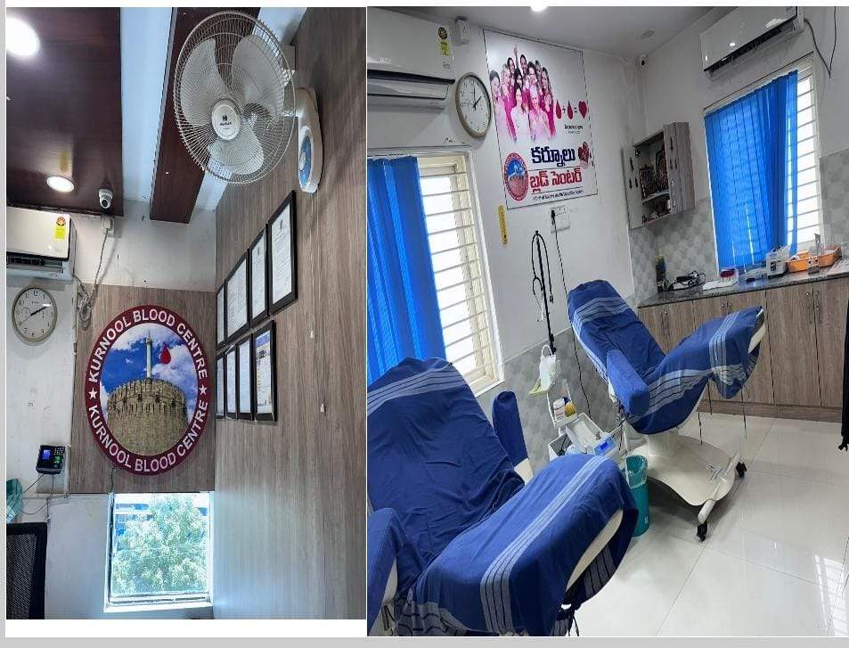

ACTIVITY LOG FOR THE SECOND WEEK

DAY  & DATE | BRIEF DESCRIPTION OF THE DAILY ACTIVITY | LEARNING OUTCOME | Person In-charge Signature
Day –  1 | We asked they collect donors | Finding of information
Day - 2 | We came to know that they conduct blood campaigns | Found
Day –  3 | They conduct blood campaigns | Different types of blood groups
Day –  4 | They give awareness about donating blood | Awareness
Day –  5 | We gathered information how many donors come forward | Information
Day –  6 | We have discussed information gathered in this week | Discussion

WEEKLY REPORT
WEEK – 2 (From Dt………..….. to Dt… )

Objective of the Activity Done:
Visited the place where need to be continued.
Detailed Report:
Last week we went to health centre and collected information so this is second week.
We requested them about our project and took permission from them then we asked them what are the problems they face when some one doesn’t find the blood group they require.

We tried to give the information we collected from the internet how they can increase more awareness by conducting the blood camps and how they can educate the people.
We also made a small survey and gathered information how people are participating in these blood donation camps.
We gained a better understanding of blood group distribution and blood level variations among patients at health centre.
There are 4 main blood groups (types of blood) – A, B, AB and O. Your blood group is determined by the genes you inherit from your parents.
The 2 major classifications of blood are the ABO system and the Rh system.
The 4 blood groups are A, B, AB and O. Each of these will be either Rh-positive or Rh-negative.
Of the eight main blood types, people with type O have the lowest risk for heart attacks and blood clots in the legs and lungs.
Group AB individuals have neither anti-A nor anti-B antibodies in their plasma. Group AB plasma can therefore be given to patients of any ABO blood group and is often referred to as the universal plasma donor.
Blood type O negative (O-) is the universal donor. This means that a person with any other blood type can safely receive your blood.
The immune system's strength and efficiency depend on various factors such as genetics, lifestyle, and overall health. Blood type does not directly determine the strength of one's immune system.
Blood groups were discovered in 1901 by an Austrian scientist named Karl Landsteiner. Before that, doctors thought all blood was the same, so many people were dying from blood transfusions.
Now experts know that if you mix blood from two people with different blood types, the blood can clump, which may be fatal.
it’s important for the donor and the recipient to have blood types that go together. People with blood group A can safely get group A blood, and people with blood group B can receive group B blood.
It’s best when a donor and recipient are an exact match and their blood goes through a process called crossmatching. But the donor doesn’t always need to have the exact same type of blood as the person receiving it. Their types just have to be compatible.
Over the past decade, there have been many claims about a so-called blood type diet, in which you eat specific foods for your blood type in order to lower your risk of certain diseases and improve your overall health.
If the mother is Rh-negative her immune system treats Rh-positive fetal cells as if they were a foreign substance. The mother's body makes antibodies against the fetal blood cells.
Any blood group person can marry any person with any blood group.

ACTIVITY LOG FOR THE THIRD WEEK

DAY  & DATE | BRIEF DESCRIPTION OF THE DAILY ACTIVITY | LEARNING OUTCOME | Person In-charge Signature
Day –  1 | We met with the supervisor, started research on dietary factors affecting blood levels | Starting research
Day - 2 | We gathered information on how different macronutrients, micronutrients and bioactive compounds affect blood levels | Information
Day –  3 | We learned the effects of dietary patterns and meal timing on blood level | Got to know the information
Day –  4 | Assess how hydration, alcohol and caffeine affect blood levels | Assess
Day –  5 | We explored the impact of food processing, preparation and supplements | Exploration
Day –  6 | Reviewed the gathered information of  this week | Review

WEEKLY REPORT
WEEK – 3 (From Dt………..….. to Dt… )

Objective of the Activity Done: How the dietary factors contribute variations in blood levels

Detailed Report: Last week we went to the health center and gathered information so this is third week
We met with the supervisor and asked if we could start research on how dietary factors affect
blood levels
We collected data from people on their current eating habits and begin tracking their dietary intake
We saw how doctors keep check on the diet of the patient
We got to know about the importance of diet in maintaining healthy blood levels for living a healthy lifestyle
Next week we are going to find about the members who can donate blood and who cannot donate blood
If the mother is Rh-negative, her immune system treats Rh-positive fetal cells as if they were a foreign substance. The mother's body makes antibodies against the fetal blood cells.

Any blood group person can marry any person with any blood group. The marriage is not linked with any blood group.
If you are not blood type O, your ABO gene can put you at risk for heart issues. This is especially true if you live in an area with high pollution levels. It can increase the risk of coronary artery disease in blood types A, B, and AB.
The oldest blood type, Type O's make up 40% of the population
Dating back as far as we can track, Blood Type O shows up in both ancient tribes and current members of isolated tribes. Part of what made the Black Plague so deadly was the susceptibility of Type O's.
A person having Rh factor in blood is called Rh positive whereas that who does not carry this protein in the blood is called Rh negative.
Marriage should be avoided in between Rh-negative.
This can be fatal for the mother as well as the baby of such parents.
The 2 major classifications of blood are the ABO system and the Rh system.
The 4 blood groups are A, B, AB and O. Each of these will be either Rh-positive or Rh-negative.
In an emergency, a transfusion of O negative red blood cells can be given to anybody, but it is better to match the exact blood group to avoid serious reactions.
The circulatory system consists of the heart, blood vessels and blood.
The blood carries oxygen and nutrients to every cell in the body and picks up waste products (such as carbon dioxide) for removal from the body.
The bulk of your blood is made up of plasma
Floating in the plasma are red blood cells that carry oxygen, the white cells that form part of the system.
The 2 main ways to classify blood groups are the ABO system and the Rh system.

ACTIVITY LOG FOR THE FOURTH WEEK

DAY  & DATE | BRIEF DESCRIPTION OF THE DAILY ACTIVITY | LEARNING OUTCOME | Person In-charge Signature
Day –  1 | To gather information on the eligibility and ineligibility criteria for blood donors | Gathering  information
Day - 2 | We identified the reasons why some people cannot donate blood | Recognized
Day –  3 | We understood special cases and recommendations provided for potential doctors | Understood
Day –  4 | We got to know about the common myths and misconceptions of blood donations | Got to know about the data
Day –  5 | We explored the collaboration with local blood banks to facilitate blood donation drives | Investigated
Day –  6 | We got a final review of the  information gathered this week | Final review

WEEKLY REPORT
WEEK – 4 (From Dt………..….. to Dt… )

Objective of the Activity Done: To know about the eligibility and ineligibility criteria for blood
Donors
Detailed Report: We collected information regarding the given data in this fourth week

We started our research and got know to know that there are some conditions for people who are eligible to donate blood regarding their age, weight, health status, valid identification e t c
The Haemoglobin level and blood pressure requirements should also be acceptable

We gathered information about the people who are ineligible for blood donation are the people who are
having medical conditions, infections, medications, involved in high risk behaviours

The people with recent surgeries and vaccinations, recent travel history and pregnant women are also ineligible for blood donation
There are also some additional considerations in blood donation type that differ in whole blood
donation
Platelet donation, plasma donation

Blood donation eligibility and ineligibility criteria are essential for ensuring the safety and effectiveness of the blood supply

The 4 different blood groups in the ABO system are A, B, AB and O. A person's blood group is determined by a pair of genes - one gene inherited from each parent.
Each blood group is identified by its own set of molecules (called antigens), which are located on the surface of red blood cells.
When a person needs a blood transfusion, the donated blood must match the recipient's blood or complications will occur.
A person's blood type used to be called their 'Rhesus type' but now we say 'Rh type'. Your Rh type is determined by a different pair of genes to the ones that determine your ABO blood type (again, one inherited from each parent).
Blood is either Rh-positive or Rh-negative, depending on whether certain molecules are present. A person who is Rh-negative will experience a severe immune-system reaction if Rh-positive blood gets into their bloodstream.
A person's blood group is described by the appropriate letter (A, B, AB or O) and by whether their blood is Rh-positive or Rh-negative.
According to Australian Red Cross Lifeblood, the percentage of blood group frequency
Problems can occur during pregnancy if a Rh-negative woman carries a Rh-positive baby.
HDN is now rare, since Rh-negative mothers are immunised throughout their pregnancy and within 72 hours of giving birth
This means on top of being matched by ABO and Rh type, the donor's blood is matched to make sure it doesn't contain blood group variants that aren't present in the recipient's blood.
All blood does the same thing, but not all blood is the same.
Blood types classify blood so healthcare providers can determine whether one person’s blood is compatible with another’s.
Blood transfusions and organ transplants depend on donors and recipients having compatible blood types. Blood types include A, B, AB and O.
A blood type is a classification system that allows healthcare

ACTIVITY LOG FOR THE FIFTH WEEK

DAY  & DATE | BRIEF DESCRIPTION OF THE DAILY ACTIVITY | LEARNING OUTCOME | Person In-charge Signature
Day –  1 | To discuss and know about the Hemoglobin levels in men and women | Discussion
Day - 2 | We collected information on how the Hemoglobin levels differ in men and women | Collected info
Day –  3 | We got to know about the biological differences between men and women that affect Hemoglobin levels | Got to know the information
Day –  4 | We explored that the hemoglobin levels can also vary with seasonal variations and dietary influences | Explored
Day –  5 | We discovered that the health conditions also play an important role in affecting hemoglobin levels | Discovered
Day –  6 | We had a discussion regarding the  information gathered this week | Discussed

WEEKLY REPORT
WEEK – 5 (From Dt………..….. to Dt… )

Objective of the Activity Done: To know how the Hemoglobin levels differ in men and women
Detailed Report: We gathered information regarding the given data in this fifth week
We started our research about how the Hemoglobin levels differ in men and women and how much
Hemoglobin is necessary in men and women
The differences in Hemoglobin levels between men and women are due to a combination of hormonal, physiological, dietary, genetic factors
Higher levels of testosterone in men leads to higher Hemoglobin levels, while women lose blood each month during periods which leads to lower Hemoglobin levels

Ensuring a healthy diet by including proper iron intake and making positive lifestyle changes can maintain and improve Hemoglobin levels
Hemoglobin levels can vary with seasons.
Health conditions can also affect Hemoglobin levels
Hemoglobin levels decrease with age in both men and women.
A blood type is a classification system that allows healthcare providers to determine whether your blood is
compatible or incompatible with someone else’s blood. There are four main blood types: A, B, AB and O.
Blood bank specialists determine your blood type based on whether you have antigen A or B on your
Red blood cells. They also look for a protein called the Rh factor. They classify your blood type as positive (+) if you have this
Typically, levels might be higher in winter and lower in summer due to changes in physical activity and hydration status

ACTIVITY LOG FOR THE SIXTH WEEK

DAY  & DATE | BRIEF DESCRIPTION OF THE DAILY ACTIVITY | LEARNING OUTCOME | Person In-charge Signature
Day –  1 | Identification of places of blood banks  in Kurnool Urban | Finding blood  banks
Day – 2 | We met the Medical Officer of The Kurnool Blood Centre for permission | NR Peta, Kurnool
Day –  3 | We gathered information regarding blood bank storage capacity | Interacted
Day –  4 | We came to know about Blood Donation procedure with the supervisors and donors | Information
Day –  5 | We observed the supply of blood to  required emergency patients | Observation
Day –  6 | We got to know about Blood Transfusion and Blood donation to others | Awareness

WEEKLY REPORT
WEEK – 6 (From Dt………..….. to Dt… )

Objective of the Activity Done: To know about The Blood Transfusions
Detailed Report: We gathered information regarding the given data in this sixth week

We started our research about The Blood Transfusion and the importance of Blood donation.

Blood Transfusion is a medical procedure in which blood or blood components are

transferred from one person (the donor) into the bloodstream of another

Person (the recipient). This process is vital for various medical conditions,

including severe blood loss due to trauma, surgery, or medical conditions such as

anemia, cancer and blood disorders.

We got to know about the importance of blood donation

Many treatments for chronic illnesses, such as cancer, require regular blood

transfusions and Blood donations are crucial in saving the lives of people who need

a blood transfusion due to accidents, surgeries or medical conditions.

Regular blood donations help maintain an adequate supply of blood and blood

products in hospitals and clinics, they can also be beneficial for donors, as it may
reduce the risk of certain health conditions and helps in maintaining a healthy

cardiovascular system.

Donating Blood is a way of giving back to the community and helping ensure that

blood is available for those in need.

Overall, blood donation is a vital act of generosity that can have a profound impact on the health and
well-being of others
it is important to know blood groups for all healthiest persons with
the legs and lungs.
This may be because people with other blood types have higher levels of certain clotting factors, which are
proteins that cause blood to coagulate

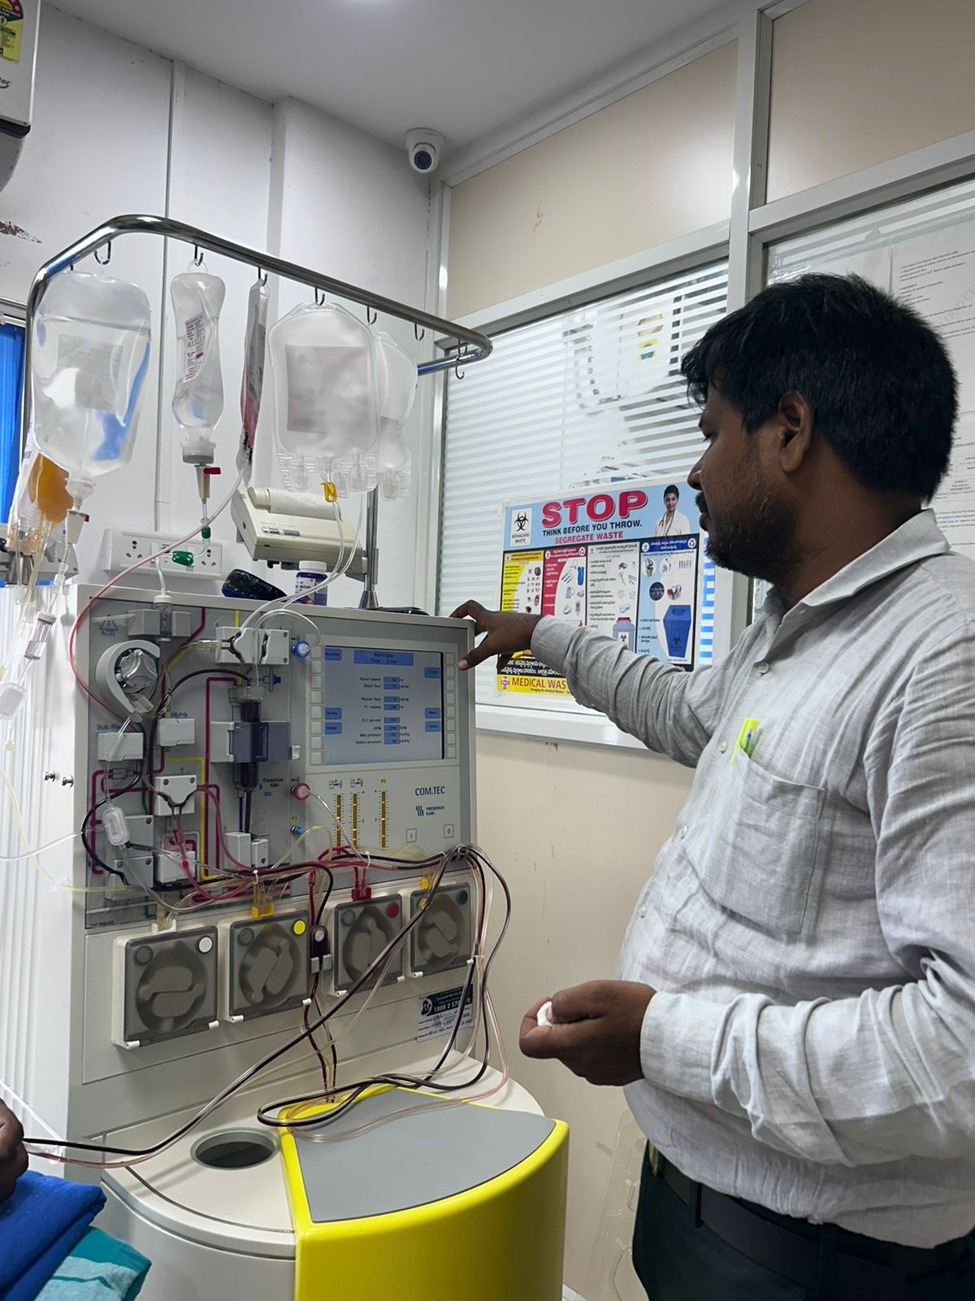

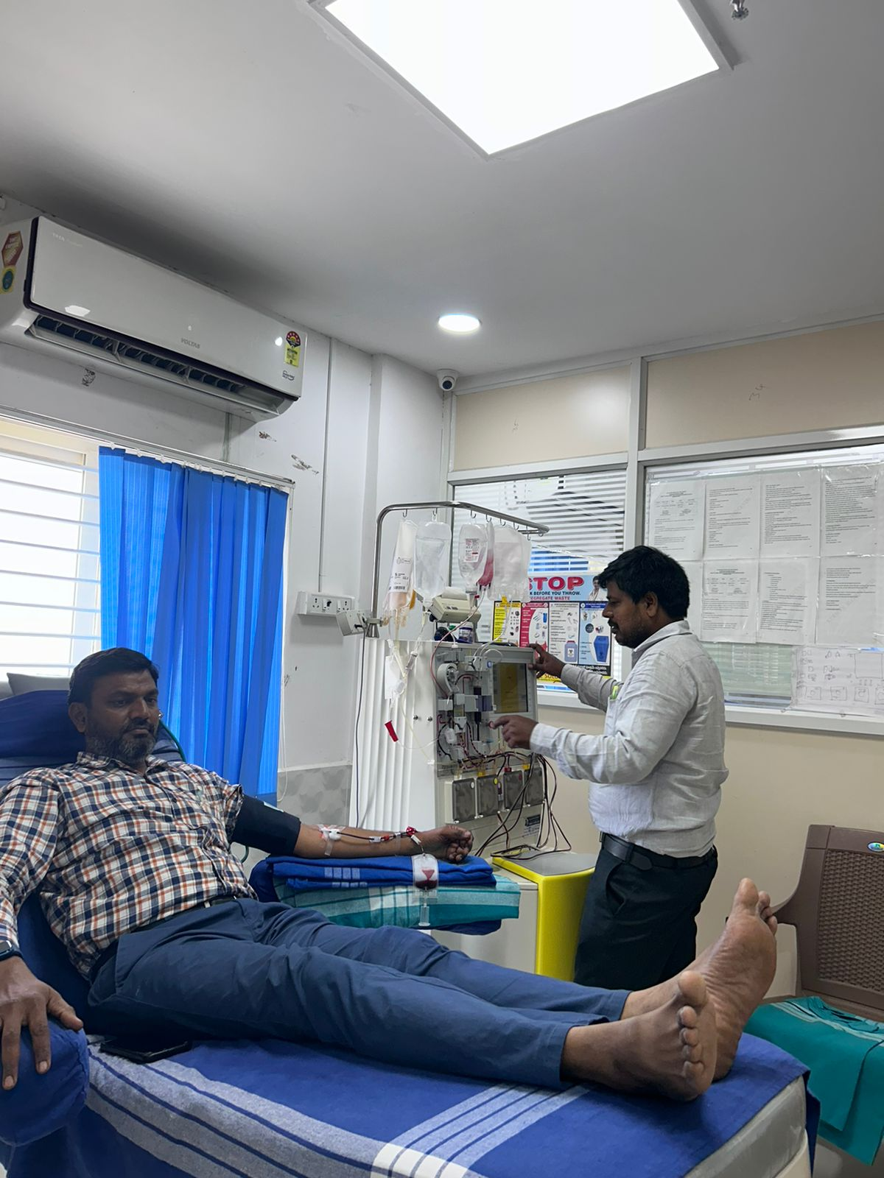

ACTIVITY LOG FOR THE SEVENTH WEEK

DAY  & DATE | BRIEF DESCRIPTION OF THE DAILY ACTIVITY | LEARNING OUTCOME | Person In-charge Signature
Day –  1 | We came to know about the normal Hb level in Men is 14 to 18 g/dl and Women is 12 to 16g/dl. | got to know about the normal hb level
Day - 2 | We came to know what happens if the hemoglobin level is low | Tiredness, weakness & shortness of breath
Day –  3 | We got to know about the difference between hemoglobin and myoglobin | Got to know about the difference
Day –  4 | We gather information about Low  hemoglobin and high hemoglobin | Gathering  information
Day –  5 | We understood why anemia and polthemia occurs | Understood
Day –  6 | We learned about complexities in different hb levels by discussing with medical doctor | Discussion

WEEKLY REPORT
WEEK – 7 (From Dt………..….. to Dt… )

Objective of the Activity Done: To know about complexities about different hemoglobin levels.

Detailed report: We started our research about complexities
We started our research about complexities about different
haemoglobin results.

Low hemoglobin levels can lead to symtoms like fatigue,
weakness, shortness of breath, and dizziness which is known as Anaemia.
Anemia is due to several reasons such as Iron deficiency, Vitamin

B12 or folate deficiency, chronic diseases and other genetic disorders.
High haemoglobin levels can increase blood viscosity which may
lead to increased risk of thrombosis (blood clots), stroke, and
.
heart problems which is known as Polythemia.

Polythemia is due to disorder where bone marrow produces too

many RBCs and other factors such as chronic hypoxia (e.g., due

to lung disease), certain tumors (renal cell carcinoma),

certain medications (e.g., erythropoietin therapy).

Both anemia and polycythemia are the conditions that require

medical evaluation and management to address

underlying causes and prevent complications associated with

abnormal blood cell counts.

Hemoglobin is found all over the body where as myoglobin is found only in muscle tissues
Blood is made up of red blood cells, white blood cells and platelets in a liquid.
called plasma. Your blood group is identified by antibodies and antigens in the blood.

ACTIVITY LOG FOR THE EIGTH WEEK

DAY  & DATE | BRIEF DESCRIPTION OF THE DAILY ACTIVITY | LEARNING OUTCOME | Person In-charge Signature
Day –  1 | We visited The Kurnool blood centre, we perceived Medical officer room, the Phlebotomy room, counselling room, apheresis room and refreshment room. | NR Peta, Kurnool
Day - 2 | We met the doctor and gathered  information about the blood | Information
Day –  3 | We observed the person who donated blood to blood centre in apheresis room. | observed.
Day –  4 | To gather information on the advancements in blood-related research and technology. | We got to know about blood research
Day –  5 | We the understood the value of blood and blood donation. | Understood
Day –  6 | We discussed with doctor and clarified about the blood | Discussion

WEEKLY REPORT
WEEK – 8 (From Dt………..….. to Dt… )

Objective of the Activity Done: To know about the advancements in blood related research and technology.

Detailed Report: We gathered information regarding the
given data in this eighth week We started our research

about Advancements in blood-related research and technology.

Advancements in blood-related research and technology have

significantly enhanced our understanding of blood disorders,

improved diagnostic capabilities, and revolutionized treatment options.

Here are some notable advancements:

1.Genomics and Molecular Diagnostics: Next-Generation Sequencing (NGS):
Allows for rapid and comprehensive analysis of genetic mutations associated with
blood disorders like leukemia, lymphoma, and inherited anemias
2.Precision Medicine: Targeted Therapies: Drugs designed to specifically target molecular abnormalities in blood cancers,

improving treatment efficacy and reducing side effects compared to traditional chemotherapy.

3.Stem Cell Research: Stem Cell Transplantation: Advancements in donor matching, conditioning regimens,
and supportive care have expanded the availability and success of stem cell transplants for various blood
cancers and genetic disorders
4.Immunotherapy: CAR-T Cell Therapy: Engineering patients' own
T cells to target and destroy cancer cells in leukemia and
lymphoma, leading to durable remissions in some cases.

5.Biotechnology and Therapeutics: Erythropoiesis-Stimulating
Agents (ESAs): Synthetic versions of erythropoietin to treat anemia

associated with chronic kidney disease and chemotherapy. Hematopoietic Growth
Factors: Stimulating production of blood cell.

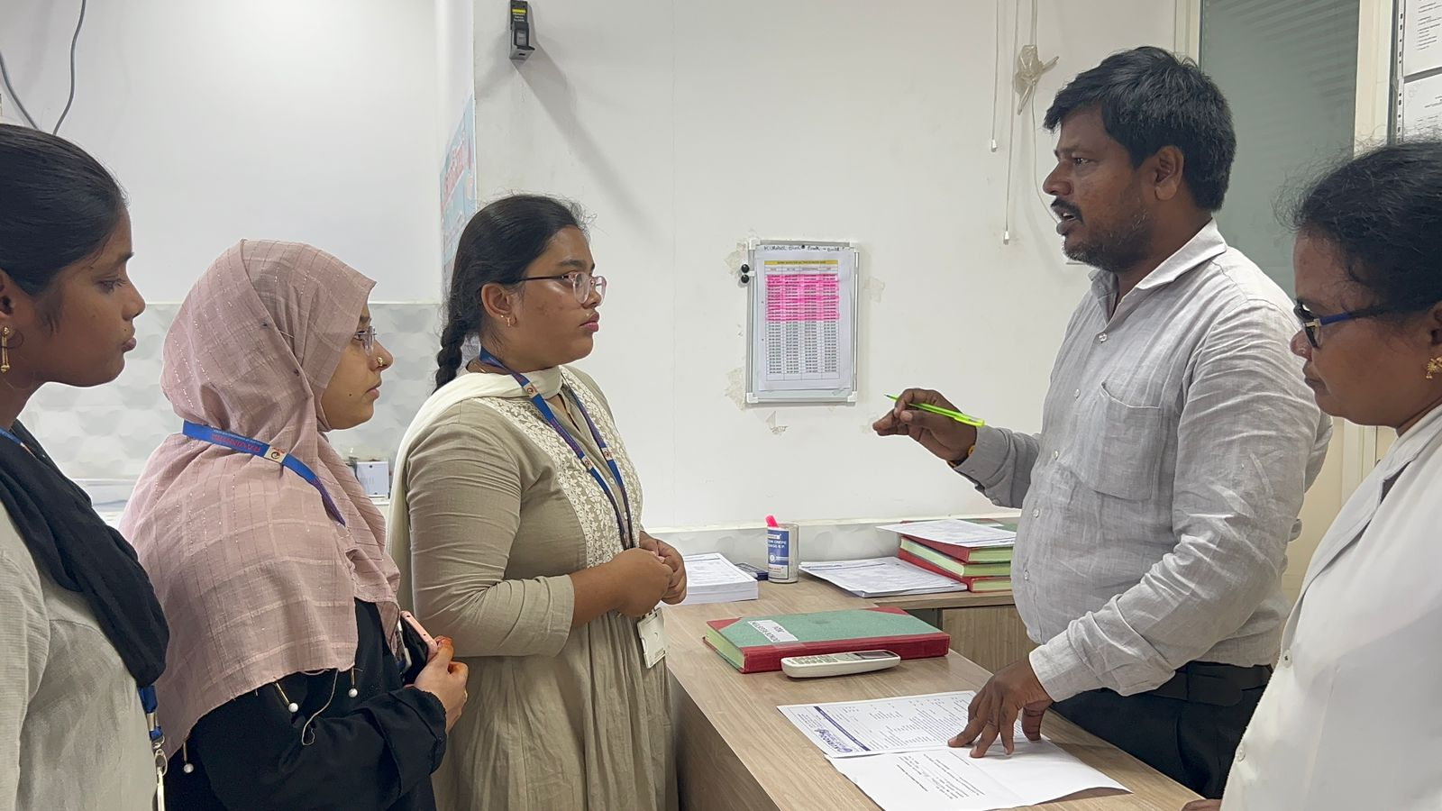

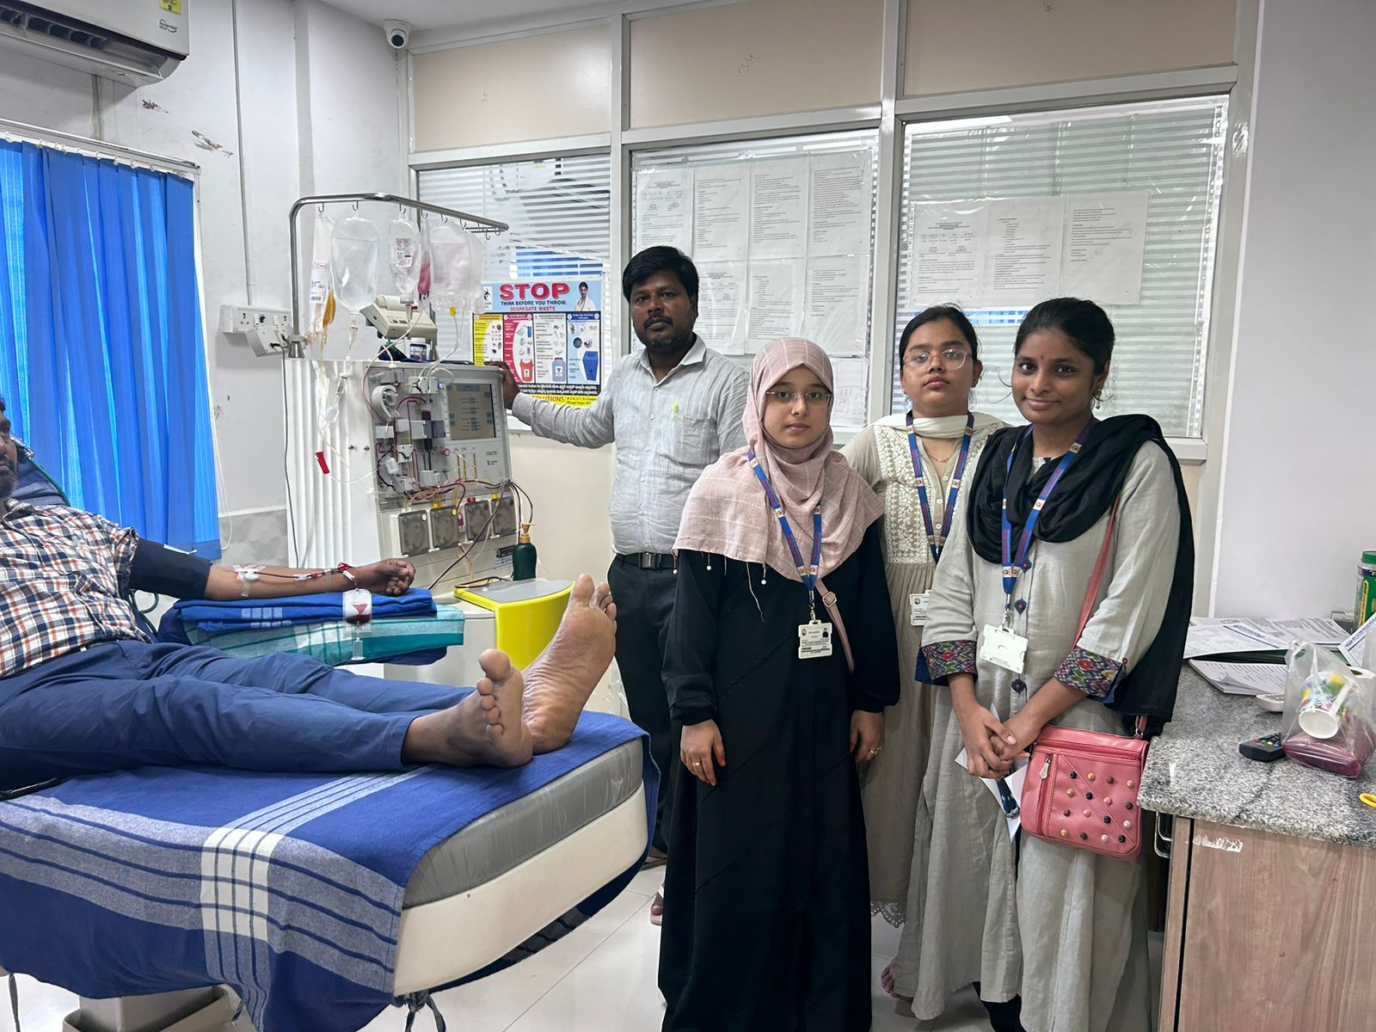

CHAPTER 5: OUTCOMES DESCRIPTION

Details of the Socio-Economic Survey of the Village/Habitation. Attach the questionnaire prepared for the survey.
1) Do you have any chronic illnesses?

2) Do you take any regular medications?

3) How did you find out your blood group?

4) Have you had a Complete Blood Count (CBC) test in the last year?

5) If yes, please provide the following details from your most recent CBC test?

6) Do you have a history of any blood disorders?

7) Do you take any dietary supplements?

8) Have you ever received a blood transfusion?

9) Is there any additional information you would like to provide regarding your blood health?

10) Is there a history of cardiovascular diseases in your family?

11) Do you feel your workplace environment affects your health?

12) Have you ever been exposed to hazardous materials at work?

13) Do you use personal protective equipment (PPE) at work?

14) Have you received workplace health and safety training?

15) Have you ever been hospitalized for any reason?

16) How many hours of sleep do they need to get on an average night?

17) Do you think the company should offer incentives for blood donation?

18) How often should the company organize blood donation drives?

19) How often should the company offer health check-ups?

20) Do you have any suggestions for improving blood health awareness?

Describe the problems you have identified in the community

1)Lack of awareness

Unawareness of Blood Groups: Many community members do not know their blood group, which is crucial in emergencies.

Health Risks: Ignorance about blood group and blood level information can lead to delayed or improper medical treatment.

Educational Deficits: There is a lack of education on the importance of blood group knowledge and maintaining healthy blood levels.

2) Insufficient Testing Facilities:

Limited Access: Few facilities are available for blood group and blood level testing, restricting access for many individuals.

Resource Constraints: Existing facilities may be poorly equipped or understaffed, reducing the effectiveness of blood testing services.

Geographical Barriers: Remote or rural areas may have no access to testing facilities, leaving many without essential health information.

3) Low Blood Donation Rates:

Infrequent Donation Drives: Blood donation drives are not conducted regularly, leading to a shortage of blood supply.
Lack of Incentives: There are few incentives or encouragements for community members to donate blood.

Social and Cultural Stigmas: Cultural beliefs and misconceptions may deter people from participating in blood donation.

4) Poor Record-Keeping:

Inadequate Documentation: Medical records, including blood group and blood level information, are often not properly maintained.

Difficulty in Emergencies: Lack of records can complicate and delay the provision of timely medical care during emergencies.

Data Loss: Poor record-keeping practices can lead to loss of crucial health information over time.

5) Emergency Preparedness:

Lack of Preparedness: Communities are often unprepared for emergencies requiring rapid blood transfusions.

Stock Management: Poor management of blood stock levels can lead to shortages during crises.

6) Health Inequalities:

Disparities: Significant disparities in access to blood testing and health services among different socioeconomic groups.

Short-term and Long-term action plan for possible solutions for the problems identified and that could be recommended to the concerned authorities for implementation.

Awareness campaigns

- Increase importance of blood donation among students and staff

- Organize seminars and workshops on blood donation around the campus

Blood donation drives

- Collect sufficient blood units to meet immediate needs.

- Provide incentives such as certificates, snacks, and small gifts to donors

Database Creation

- Maintain a record of willing blood donors and their blood groups.

- Develop an online database or mobile for registering potential doctors

Partnership with local hospitals

- Establish agreements with nearby hospitals for priority access to blood.

- Set up a communication protocol for urgent requests

Establishment of a Permanent Blood Donation Centre

- Provides a consistent and reliable source of blood for the community.

- Equip the centre with necessary medical supplies and staff.

- Promote the centre’s services to ensure regular donor turnout

Regular monitoring and reporting

- Implement a system for regular monitoring of blood stock levels

- Publish periodic reports on blood donation statistics and needs.

- Use data to identify trends and plan future donation drives

Community Engagement and outreach

- Extend blood donation efforts beyond the campus.

- Collaborate with local community organizations and schools to raise awareness

- Organize joint blood donation drives with community groups.

Description of the Community awareness programme/s conducted w.r.t the problems and their outcomes.
Blood Donation Awareness Campaigns
- Increased awareness and understanding of the importance of blood donation.

- Higher engagement and interest among students and staff

- Greater social media reach, with many students by sharing posts

Educational Integration and curriculum development
- Increased knowledge and awareness about blood donation among students.

- Encouraged academic interest and research in topics related to blood donation and public health

- Incorporated blood donation education into health and biology courses

Community Engagement and Outreach programs
- Collaborated with local community organizations and schools to raise awareness about blood donation.

- Organized local blood donation drives with community groups to increase participation

- Strengthened community ties and built a network of support for ongoing blood donation efforts.

Database Creation and Registration drives
- Created a comprehensive and accessible donor database

- Improved coordination and communication for organizing blood donation drives

Partnerships with Local hospitals and Health services
- Enhanced ability to respond promptly to emergency blood requirements.

- Strengthened cooperation and trust between the institution and local healthcare providers

- Improved overall efficiency and effectiveness of the blood donation program.

Health Fairs and Blood Donation Workshops
- Increased engagement and interest through interactive and practical learning experiences

Emergency Preparedness and Response Drills
- Trained volunteers and staff on protocols for managing blood donation during disasters

- Strengthened coordination between the institution, local hospitals, and emergency services.

Report of the mini-project work done in the related subject w.r.t the habitation/village.

A mini-project work in the related subject w.r.t the habitation/village. (For ex., a student of Botany may do a project on Organic Farming or Horticulture or usage of biofertilizers or biopesticides or effect of the inorganic pesticides, etc. A student of Zoology may do a project on Aquaculture practices or animal husbandry or poultry or health and hygiene or Blood group analysis or survey on the Hypertension or survey on the prevalence of diabetes, etc.
The Report shall be limited to 6 pages.
PROJECT DESCRIPTION

International Society of Blood Transfusion has recently recognized 33 blood group systems. Apart from ABO and Rhesus system, many other types of antigens have been noticed on the red cell membranes. Blood grouping and cross-matching is one of the few important tests that the anaesthesiologist orders during perioperative period. Hence, a proper understanding of the blood group system, their clinical significance, typing and cross-matching tests, and current perspective are of paramount importance to prevent transfusion-related complications. Nonetheless, the knowledge on blood group system is necessary to approach blood group-linked diseases which are still at the stage of research. This review addresses all these aspects of the blood groups system

The red cells of an individual contain antigens on their surfaces that correspond to their blood group and antibodiesin the serum that identify and combine with the antigen sites on the surfaces of red cells of another type. The reaction between red cells and corresponding antibodies usually results in clumping of the red cells; therefore, antigens on the surfaces of these red cells are often referred to as agglutinogens.
ABO BLOOD GROUP
The discovery of the ABO blood group, over 100 years ago, caused great excitement. Until then, all blood had been assumed to be the same, and the often-tragic consequences of blood transfusions were not understood. As our understanding of the ABO group grew, not only did the world of blood transfusion become a great deal safer, but scientists could now study one of the first human characteristics proven to be inherited. A person's ABO blood type was used by lawyers in paternity suits, by police in forensic science, and by anthropologists in the study of different populations.
The ABO blood group antigens remain of prime importance in transfusion medicine—they are the most immunogenic of all the blood group antigens. The most common cause of death from a blood transfusion is a clerical error in which an incompatible type of ABO blood is transfused. The ABO blood group antigens also appear to have been important throughout our evolution because the frequencies of different ABO blood types vary among different populations, suggesting that a part
The ABO blood group antigens are encoded by one genetic locus, the ABO locus, which has three alternative (allelic) forms—A, B, and O. A child receives one of the three alleles from each parent, giving rise to six possible genotypes and four possible blood types (phenotypes)ocular blood type conferred a selection advantage (e.g., resistance against an infectious disease.)

Blood is a crucial biological fluid that performs essential functions in the human body, including the transport of oxygen, nutrients, hormones, and waste products. The study of blood, particularly blood groups and blood levels, is fundamental in medical science for several reasons. Blood groups, classified by specific antigens on red blood cells' surfaces, are vital for safe blood transfusions, organ transplants, and understanding genetic inheritance patterns. Blood levels, referring to the concentration of various components within the blood, are critical indicators of an individual's health status and can aid in diagnosing and monitoring a variety of medical conditions.

Literature Review

Historical Perspective
The discovery of blood groups revolutionized medical science. Karl Landsteiner's identification of the ABO blood group system in 1901 was a milestone, earning him the Nobel Prize in Physiology or Medicine in 1930. This discovery paved the way for safe blood transfusions by understanding incompatibilities between different blood types. The Rh system, discovered by Landsteiner and Wiener in 1940, further enhanced the safety of blood transfusions, particularly in pregnancy and neonatal care.

Blood Groups and Transfusion Medicine
Blood group compatibility is critical for preventing transfusion reactions, which can be life-threatening. The ABO and Rh systems are the primary focus in transfusion medicine. The universal donor (O negative) and universal recipient (AB positive) concepts are well-established, but the presence of other minor blood group antigens can also affect transfusion compatibility. The prevalence of different blood groups varies among populations, influencing blood bank management and the availability of compatible blood for patients.

Blood Levels and Health Indicators
Blood levels of various components such as hemoglobin, red blood cells, white blood cells, and platelets are vital health indicators. Hemoglobin levels reflect the oxygen-carrying capacity of the blood and can indicate conditions like anemia or polycythemia. White blood cell counts can signal infections, inflammations, or hematological disorders like leukemia. Platelet counts are essential for understanding bleeding and clotting disorders. The normal ranges for these blood components can vary based on factors like age, gender, and ethnicity.

Blood Groups and Disease Susceptibility
Emerging research has highlighted potential associations between blood groups and susceptibility to various diseases. For instance, individuals with blood group A may have a higher risk of cardiovascular diseases, while those with blood group O might be less susceptible to certain infections, including malaria. These associations can provide insights into disease mechanisms and contribute to personalized medicine approaches.

Genetic and Evolutionary Perspectives
Blood groups are inherited genetic traits. Understanding their distribution and evolutionary significance can provide insights into human migration patterns and the adaptation of populations to different environments. The diversity of blood groups across populations suggests a complex interplay between genetics and environmental factors.

Objectives
The primary objectives of this project are:
- To understand the distribution of different blood groups within a specified population.
- To analyze the variations in blood levels among individuals with different blood groups.
- To explore the correlation between blood groups and susceptibility to certain diseases.
- To evaluate the impact of demographic factors such as age, gender, and ethnicity on blood group distribution and blood levels.
- To provide data that can enhance the efficiency and safety of blood transfusions and other medical procedures.

Methodology

Study Design
This study will be observational and cross-sectional, involving participants from various demographic backgrounds. The design will ensure that the data collected provides a snapshot of the population's blood group distribution and blood levels at a specific point in time.

Participant Recruitment
Participants will be recruited from local hospitals, clinics, and community centers. Informed consent will be obtained from all participants, ensuring they understand the study's purpose, procedures, and potential risks. Inclusion criteria will include individuals aged 18 and above, with no restrictions on gender or ethnicity. Exclusion criteria will include individuals with known blood disorders or those currently undergoing blood transfusions.

Data Collection
- Blood Group Determination: Blood samples will be collected from each participant, and standard agglutination tests will be used to determine their blood group (A, B, AB, or O) and Rh factor (positive or negative). The testing will be conducted in certified laboratories to ensure accuracy.
- Blood Level Measurement: Comprehensive blood tests will be conducted to measure various components, including hemoglobin levels, red and white blood cell counts, platelet counts, and other relevant biomarkers. Automated hematology analyzers will be used to ensure accuracy and consistency in measurements.
- Demographic Information: Participants will provide information on their age, gender, ethnicity, medical history, and lifestyle factors (e.g., diet, exercise, smoking status). This information will be collected through structured questionnaires administered by trained personnel.
- Disease History and Risk Factors: Participants will be asked about their medical history, including any diagnoses of chronic diseases (e.g., cardiovascular diseases, diabetes, infections) and family history of similar conditions. This information will help explore potential correlations between blood groups and disease susceptibility.

Data Analysis
The collected data will be analyzed using statistical software. Descriptive statistics will summarize the distribution of blood groups and blood levels. Inferential statistics, such as chi-square tests and ANOVA, will be used to examine the relationships between blood groups, blood levels, and demographic factors. Regression analysis may be conducted to explore predictors of blood levels and disease susceptibility.
- Descriptive Analysis:
  - Distribution of blood groups: Frequency and percentage of each blood group (A, B, AB, O) and Rh factor (positive, negative) within the population.
  - Blood levels: Mean, median, standard deviation, and range for hemoglobin, white blood cells, and platelet counts.
- Inferential Analysis:
  - Chi-square tests: To examine the association between blood groups and categorical variables such as gender and ethnicity.
  - ANOVA: To compare the mean blood levels across different blood groups.
  - Regression Analysis: To identify predictors of blood levels and disease susceptibility, adjusting for confounders such as age, gender, and lifestyle factors.
- Correlation Analysis:
  - Pearson or Spearman correlation coefficients: To explore the relationship between continuous variables such as age and blood levels.
  - Logistic Regression: To assess the risk of diseases (e.g., cardiovascular diseases, infections) based on blood groups, controlling for potential confounders.

Anticipated Challenge
- Participant Recruitment: Ensuring a diverse and representative sample may be challenging. Strategies such as community outreach and collaboration with healthcare facilities will be employed.
- Data Accuracy: Ensuring the accuracy of self-reported demographic information and medical history. Verification through medical records and cross-referencing will be necessary.
- Ethical Concerns: Maintaining participant confidentiality and addressing any ethical concerns related to blood sample collection and data handling.

Ethical Considerations
The study will adhere to ethical guidelines set by institutional review boards (IRBs). Informed consent will be obtained from all participants, ensuring they understand the study's purpose, procedures, and potential risks. Participants will be assured of their right to withdraw from the study at any time without any consequences. Data will be anonymized to protect participant confidentiality, and secure databases will be used for data storage. Ethical considerations will also include the responsible use of the collected data, ensuring it is used solely for research purposes and not for any commercial gain.

Timeline
- Preparation Phase (Months 1-2):
  - Literature review
  - Development of study protocol and instruments
  - Ethical approval
- Recruitment Phase (Months 3-6):
  - Participant recruitment
  - Informed consent process
- Data Collection Phase (Months 7-12):
  - Blood sample collection and analysis
  - Demographic data collection
- Data Analysis Phase (Months 13-16):
  - Data entry and cleaning
  - Statistical analysis
- Reporting Phase (Months 17-18):
  - Interpretation of results
  - Preparation of final report and dissemination of findings

Potential Limitations
- Selection Bias: The study population may not be fully representative of the general population, potentially limiting the generalizability of the findings.
- Self-reported Data: Reliance on self-reported demographic information and lifestyle factors may introduce bias and inaccuracies.
- Cross-sectional Design: The observational cross-sectional design limits the ability to establish causality between blood groups, blood levels, and diseases.
- Resource Constraints: Limited resources may affect the sample size and scope of the study, potentially impacting the statistical power of the analysis.

Expected Outcomes
- Distribution of Blood Groups: The study will provide detailed information on the prevalence of different blood groups within the study population, highlighting any significant patterns or trends.
- Variations in Blood Levels: Insights into how blood levels vary among individuals with different blood groups will be obtained, potentially identifying unique characteristics associated with each blood group.
- Disease Correlation: The study may reveal correlations between specific blood groups and a higher or lower risk of certain diseases, contributing to personalized medicine approaches.
- Demographic Influences: Understanding how factors such as age, gender, and ethnicity influence blood group distribution and blood levels will enhance the applicability of the findings across diverse populations.

Detailed Implications
Improving Transfusion Practices: The data can be used to optimize blood transfusion protocols, ensuring compatibility and reducing the risk of adverse reactions. Hospitals and blood banks can better manage their blood supplies based on the distribution of blood groups within the population, ensuring that rare blood types are adequately stocked.

Enhancing Disease Prediction and Management
Understanding the correlations between blood groups and disease susceptibility can improve disease prediction and management. For example, individuals with blood group A may benefit from more frequent cardiovascular health screenings, while those with blood group O might require different preventive measures. These insights can contribute to personalized medicine, where treatments and preventive strategies are tailored to an individual's genetic profile and biological characteristics.

Advancing Public Health Policies
The findings of this study can inform public health policies and interventions. For instance, knowing the distribution of blood groups in a population can help in planning vaccination campaigns, managing blood donation drives, and preparing for emergencies that require large-scale blood transfusions. Public health authorities can also use the data to address health disparities among different demographic groups.

Contributing to Genetic and Evolutionary Research
The study's data on blood group distribution and genetic inheritance can contribute to research on human evolution and migration patterns. By understanding how blood groups have evolved and spread across different populations, researchers can gain insights into the genetic diversity and adaptability of humans. This knowledge can also shed light on the evolutionary pressures that have shaped the prevalence of certain blood groups and their associated disease susceptibilities.

Future Directions

Expanding the Study Population
Future research can expand the study population to include more diverse and larger samples, enhancing the generalizability of the findings. Longitudinal studies can be conducted to observe changes in blood levels and disease susceptibilities over time, providing a more comprehensive understanding of the relationships between blood groups and health.

Exploring New Blood Group Systems
Technological advancements continue to uncover new blood group systems and antigens. Future studies can explore these newly discovered systems to determine their clinical significance and implications for transfusion medicine, disease susceptibility, and genetic research. This ongoing research can lead to more accurate and safer transfusion practices and personalized medical approaches.

Integrating Genomic and Proteomic Data
Integrating genomic and proteomic data with blood group and blood level analyses can provide deeper insights into the molecular mechanisms underlying blood group-related disease susceptibilities. By examining the interactions between genes, proteins, and environmental factors, researchers can develop more targeted therapies and preventive strategies. This multidisciplinary approach can accelerate the discovery of novel biomarkers and therapeutic targets.

Developing Predictive Models
Advanced statistical and machine learning techniques can be used to develop predictive models that assess the risk of diseases based on blood group data and other relevant factors. These models can aid clinicians in identifying high-risk individuals and implementing early interventions, ultimately improving patient outcomes. Predictive models can also be used in public health planning and resource allocation.

Conclusion
This comprehensive study on blood groups and blood levels aims to enhance our understanding of the distribution and implications of different blood groups within a population. By analyzing variations in blood levels, exploring disease correlations, and evaluating the impact of demographic factors, the study seeks to provide valuable data for improving transfusion practices, advancing personalized medicine, and informing public health policies. The anticipated findings will contribute to a deeper understanding of the complex relationships between genetics, blood group antigens, and health, ultimately benefiting both clinical practice and scientific research.

References
(A comprehensive list of references supporting the literature review, methodology, and discussions would be included here, adhering to the appropriate citation format.)
This expanded project description provides an in-depth overview, ensuring that each aspect is thoroughly covered. The detailed sections aim to offer a holistic understanding of the study's objectives, methodologies, and potential impacts, ensuring that the document is comprehensive and informative Top of Form
Bottom of Form

CHAPTER 6: RECOMMENDATIONS AND CONCLUSIONS OF THE MINI PROJECT

Conclusions:
- High Demand for Rare Blood Types: The study confirms that certain blood types, particularly negative Rh types (e.g., B-, AB-), are significantly rarer and thus more likely to be scarce in blood banks.
- Insufficient Awareness: There is a general lack of awareness among the public about the importance of donating blood, especially rare blood types. This contributes to the scarcity.
- Seasonal Fluctuations: Blood supply often experiences seasonal fluctuations, with donations dropping during holidays and summer months when people are less available to donate.
- Mismatch Between Supply and Demand: The blood bank inventory often does not align with the actual demand in hospitals, leading to shortages in critical situations.
- Impact of Demographic Changes: Aging populations and changing demographics are affecting the availability of certain blood types, as older individuals are less likely to donate.

Recommendations:

- Enhanced Public Awareness Campaigns:
  - Launch targeted campaigns to raise awareness about the importance of donating blood, particularly focusing on rare blood types.
  - Utilize social media, community events, and educational institutions to reach a broader audience.
- Incentive Programs:
  - Implement reward programs to encourage regular donations, such as discounts, recognition, or small gifts.
  - Partner with businesses and organizations to provide incentives for employees who donate blood.
- Regular Donation Drives:
  - Schedule regular blood donation drives in schools, universities, workplaces, and community centers.
  - Collaborate with local governments and non-profits to organize these events consistently.
- Strategic Inventory Management:
  - Adopt better inventory management practices to ensure blood banks can meet the demand for all blood types.
  - Use predictive analytics to forecast demand and plan for shortages in advance.
- Improve Donor Experience:
  - Make the donation process as smooth and pleasant as possible to encourage repeat donors.
  - Provide clear information about the donation process, eligibility criteria, and the impact of donations.
- Targeted Recruitment for Rare Blood Types:
  - Identify and recruit donors with rare blood types through targeted outreach and personalized communication.
  - Maintain a registry of rare blood donors and establish a direct line of communication for urgent needs.

Student Self-Evaluation for the Community Service Project
STUDENT NAME: Maleeha Nazneen Abdul
Molla Sabeena
N.Sree Charitha
Naseeka Narmin

REGISTER NUMBER: 223T1A3125
223T1A3126
223T1A3127
223T1A3128

PERIOD OF CSP:8 WEEKS FROM: …………..
TO:……………

DATE OF EVALUATION:
NAME OF THE PERSON IN CHARGE: MRS. DEEPTHI CRESTOSE REBEKAH
ADDRESS WITH MOBILE NUMBER:
Please rate your performance in the following areas:

Rating Scale: 1 is lowest and 5 is highest rank

1) Oral communication | 1 | 2 | 3 | 4 | 5
2) Written communication | 1 | 2 | 3 | 4 | 5
3) Proactiveness | 1 | 2 | 3 | 4 | 5
4) Interaction ability with community | 1 | 2 | 3 | 4 | 5
5) Positive Attitude | 1 | 2 | 3 | 4 | 5
6) Self-confidence | 1 | 2 | 3 | 4 | 5
7) Ability to learn | 1 | 2 | 3 | 4 | 5
8) Work Plan and organization | 1 | 2 | 3 | 4 | 5
9) Professionalism | 1 | 2 | 3 | 4 | 5
10) Creativity | 1 | 2 | 3 | 4 | 5
11) Quality of work done | 1 | 2 | 3 | 4 | 5
12) Time Management | 1 | 2 | 3 | 4 | 5
13) Understanding the Community | 1 | 2 | 3 | 4 | 5
14) Achievement of Desired Outcomes | 1 | 2 | 3 | 4 | 5
15) OVERALL PERFORMANCE | 1 | 2 | 3 | 4 | 5

Date: Signature of the Student
Evaluation by the Person in-charge in the Community/Habitation

Student Name: Maleeha Nazneen Abdul
Molla Sabeena
N. Sree Charitha
Naseeka Narmin

Registration No: 223T1A3125
223T1A3126
223T1A3127
223T1A3128

From: To:

Period of CSP: From:

Date of Evaluation:

Name of the Person in-charge: MRS. DEEPTHI CRESTOSE REBEKAH

Address with mobile number:

Please rate the student’s performance in the following areas:

Please note that your evaluation shall be done independent of the Student’s self-evaluation Rating Scale: 1 is lowest and 5 is highest rank

1) Oral communication | 1 | 2 | 3 | 4 | 5
2) Written communication | 1 | 2 | 3 | 4 | 5
3) Proactiveness | 1 | 2 | 3 | 4 | 5
4) Interaction ability with community | 1 | 2 | 3 | 4 | 5
5) Positive Attitude | 1 | 2 | 3 | 4 | 5
6) Self-confidence | 1 | 2 | 3 | 4 | 5
7) Ability to learn | 1 | 2 | 3 | 4 | 5
8) Work Plan and organization | 1 | 2 | 3 | 4 | 5
9) Professionalism | 1 | 2 | 3 | 4 | 5
10) Creativity | 1 | 2 | 3 | 4 | 5
11) Quality of work done | 1 | 2 | 3 | 4 | 5
12) Time Management | 1 | 2 | 3 | 4 | 5
13) Understanding the Community | 1 | 2 | 3 | 4 | 5
14) Achievement of Desired Outcomes | 1 | 2 | 3 | 4 | 5
15) OVERALL PERFORMANCE | 1 | 2 | 3 | 4 | 5

Date: Signature of the Supervisor

PHOTOS AND VIDEO LINKS

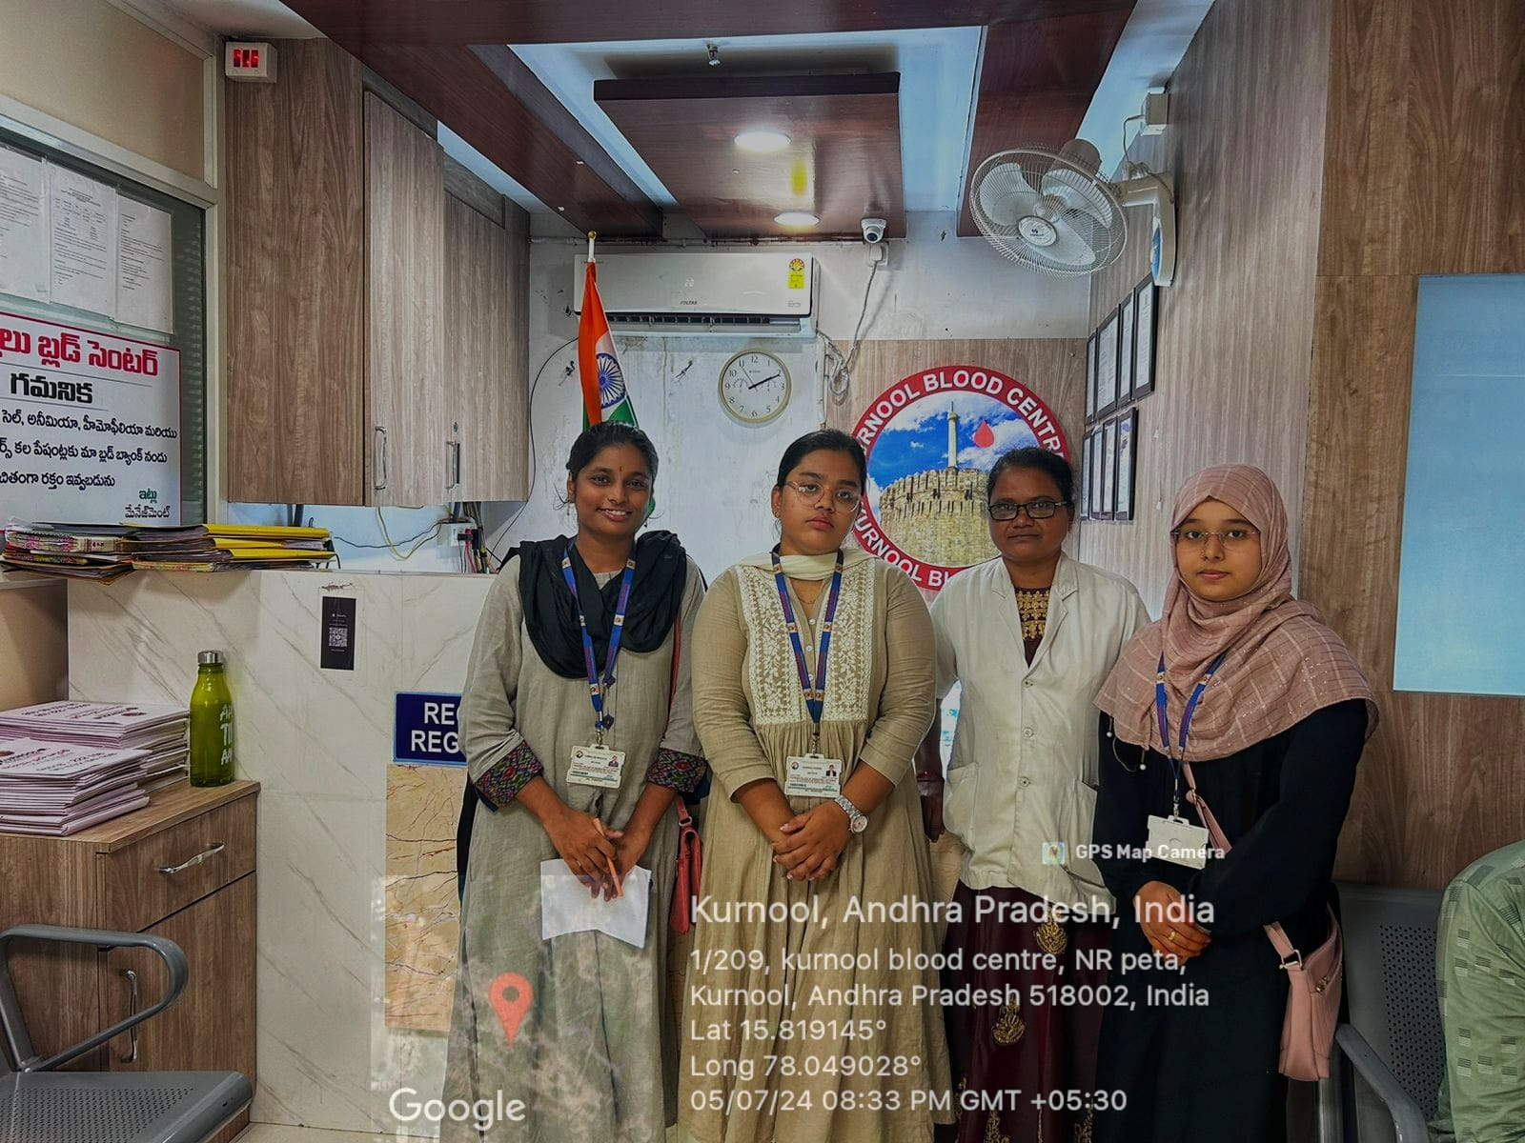

https://drive.google.com/file/d/1wY-C_jfFSqcO4teNBU1rPJko6jPmoClc/view?usp=drivesdk

